Guidelines to Use the Custom Multi-Select Widget in Catalog Items

Step 1: Create the Service Portal Widget
- In ServiceNow, create a Service Portal Widget.
- Use the HTML, CSS, Client Controller, and Server Script provided AT THE BOTTOM OF THE PAGE.

Step 2: Configure the Catalog Item Variable

Case 1: Using Predefined Choices
- Go to your catalog item and create a new variable.
- Select Select Box as the variable type. 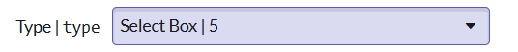
- At the bottom, create your predefined choices.
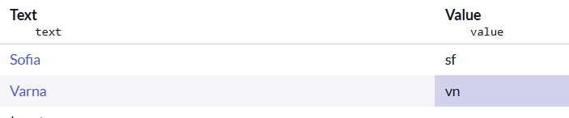
- After creating the choices, change the variable type from Select Box to Custom.
- Provide the widget name in the Type specifications.
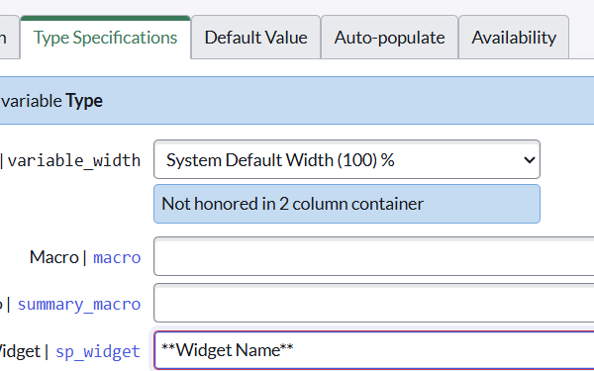

Result:
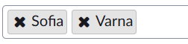

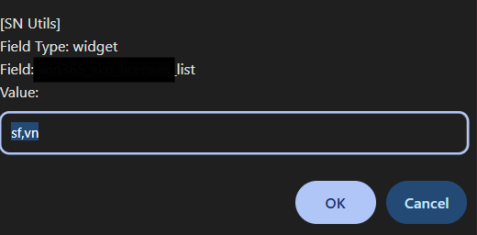

Case 2: Using Scripts to Fetch Choices Dynamically
- Create a Custom variable and link it to the widget. No question choices are needed.
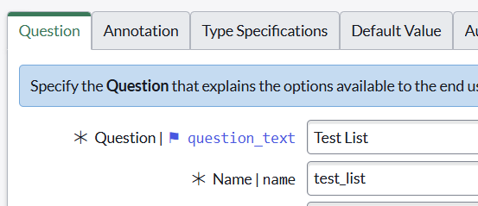

- Create a new variable of type Single Line Text.
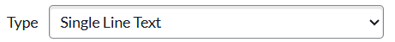
- Name this variable the same as the first variable, but add hidden_ at the beginning.
  - This ensures the logic associates this variable with the first one.
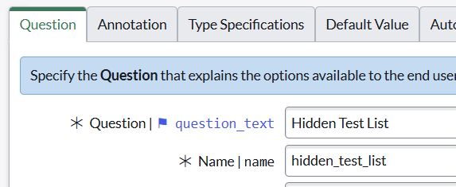
- In the hidden variable, provide a script in the Default Value field.
  - Example: Call a Script Include that returns filtered options (e.g., filtered licenses).
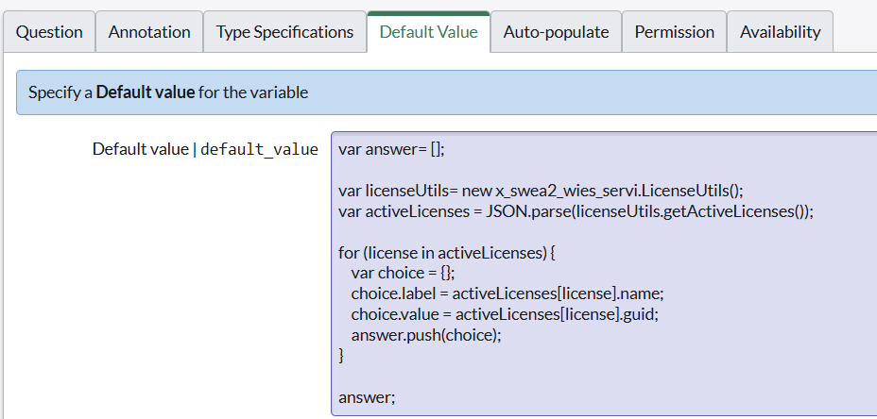

Result:

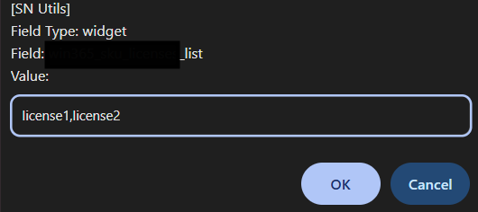

Multiple-selection Widget

HTML:

CSS:

Client Controller

Server Side Script

